
Company
Logotype

Cone Beam Computed Tomography- Report



Porur Dental X-rays & CBCT

Patient Name : Mrs. Saratha | Date of Report : 24.03.2024
Age/ Gender : 63 years/ Female | Region of Interest : CBCT Full Skull
Referring doctor: Dr. Godwin | Indication : Implant assessment
Clinical Notes: Nil
PATIENT INFORMATION

CBCT- Full Skull provided
CBCT – IMAGE DETAILS

RADIOGRAPHIC INTERPRETATION

- Partial loss of crown structure in relation to: 26, 37, 45.
- In 17, the crown is present with diffuse hypodense area involving enamel, dentin and pulp, leading to diffuse periapical hypodensity.
- The alveolar ridge in relation to the maxillary and mandibular alveolar ridge is present with normal trabecular pattern.

IMPLANT ASSESSMENT

 | 17 region | 26 region
Sub-Crestal (in mm) | 15.1 | 11.3
Mid- Crestal (in mm) | - | 11.9
Distance between the alveolar ridge and floor of the maxillary sinus (in mm) | 3.3 | 10.1
 | 37 region | 45 region
Sub-Crestal (in mm) | 9.3 | 7.1
Mid- Crestal (in mm) | 11.4 | 8.7
Distance between alveolar ridge and the inferior alveolar nerve canal (in mm) | 12.5 | 16.8
Distance between alveolar ridge and the inferior border of mandible (in mm) | 25.5 | 29.1

RADIOGRAPHIC IMPRESSION

- Fractured crown: 26, 37, 45.
- Dental caries with periapical pathology: 17.

Kindly correlate with clinical findings


IMAGES FOR REFERENCE

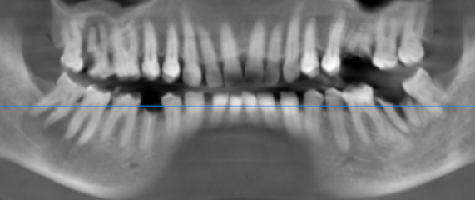

3-DIMENSIONAL VIEW

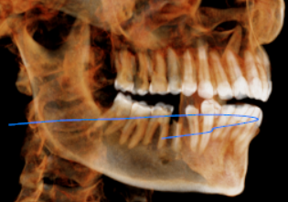
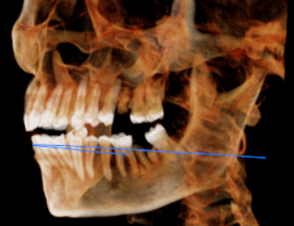

CROSS SECTIONAL VIEW

17 region | 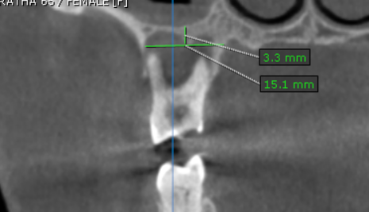
26 region | 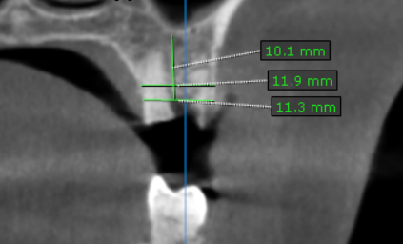
37 region | 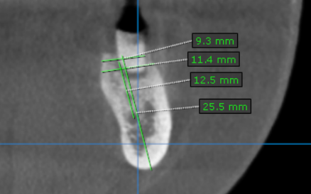
45 region | 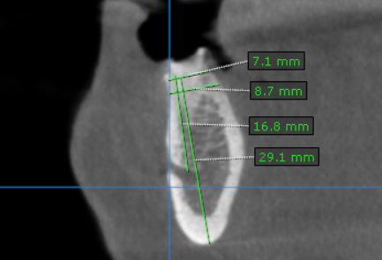

**** End of report ****

